PROGRAM :
#include<stdio.h>
#include<string.h>
void main()
{
char s[100];
int i,flag,flag1,a,b;
int l;
printf("enter a string to check:");
scanf("%s",s);
l=strlen(s);
flag=1;
for(i=0;i<l;i++)
{
if(s[i]!='0' && s[i]!='1')
{
flag=0;
}
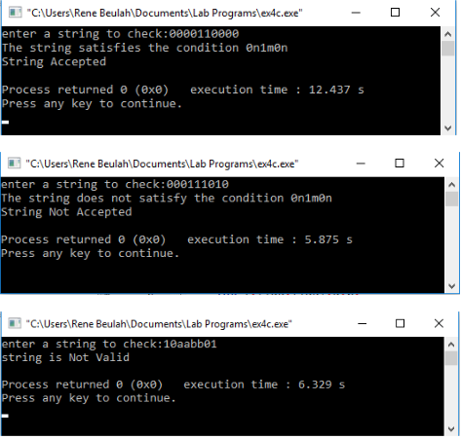
}
if(flag!=1)
printf("string is Not Valid\n");
if(flag==1)
{
flag1=1;
a=0;b=l-1;
while(a!=(l/2))
{
if(s[a]!=s[b])
{
flag1=0;
}
a=a+1;
b=b-1;
}
if (flag1==1)
{
printf("The string is a palindrome\n");
printf("string is accepted\n");
}
else
{
printf("The string is not a palindrome\n");
printf("string is Not accepted\n");
}
}
}

